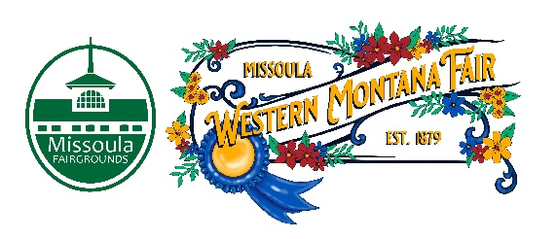

Missoula County Fair Event Committee
Thursday, January 11, 2024 at 10:00 a.m.
Fair Office, Building #12
Missoula County Fairgrounds
1101 South Avenue West, Missoula, MT 59801

Committee Members

- Jim Sadler – Chair
- Dave Bell - Vice-Chair
- Sarah Knobel
- Brooke Martin
- Tonya Robert
- Jane Kelly
- Hailey Jo Bergstrom

Meeting Minutes

- Meeting commencement
  - Vice Chair Dave Bell called the meeting to order at 10:00 a.m. Dave Bell, Sarah Knobel, Brooke Martin, Tonya Robert, Jane Kelly, Hailey Jo Bergstrom, Campbell Barrett, Allison Wilson, Jacey Grange & Billie Brown were present.
- Rollcall & Introductions
- Approval of Agenda
  - Agenda has been approved for January.
- Public comment on items not on the agenda
  - None
- Action Items
- Approval of December 14th, 2023, minutes.
- Discussion Items
- Western Montana Fair
  - Food Vendor Application
    - All vendor applications (concession, commercial, and amusement) are open and can be found on the Missoula Fairgrounds website as of January 8th, 2024.
  - WMF Legends Award
    - The WMF Legends Award application is now live on the Missoula County Fairgrounds website.
      - Jane requests that nominator submits a resume for the nominee. Brooke requests that 2023 winner presents award to 2024 winner.
  - Rodeo Stock Contractor
    - Cervi Rodeo will be the stock contractor for the 2024 Missoula Stampede Rodeo. The proposed schedule of events for the 2024 Missoula Stampede are as follows:
      - Tuesday, 8/6: Xtreme Bulls
      - Wednesday, 8/7: Rough stock night with barrel racing and mutton busting. The official name for Wednesday night is being brainstormed.
      - Thursday, 8/8, - Saturday, 8/10: Missoula Stampede Rodeo with mutton busting
- 4-H Update
  - Campbell reported that the 70 beef were weighed at Market Beef weigh-in. 4-H enrollment numbers have increased compared to January 2023. 4-H participants are utilizing the new space at the Extension Office for workshops and other learning opportunities. 4-H Program Assistant, Deidad Wright, resigned from the Missoula County MSU Extension Office.
- Development Update
  - Clouse Bauer Arena
    - The County Commissioners approved the construction bid for the Clouse Bauer Arena on Tuesday, 1/9/2024.
  - Other
    - The Fairgrounds signed a contact with Always On, LLC. Always On, LLC will produce a music festival at the Fairgrounds during Fourth of July weekend starting in July 2025.
    - Billie Brown and Emily Brock have been attending neighborhood meetings in Midtown to discuss how the Fairgrounds is expanding as an event center.
- Adjournment
  - Meeting adjourned at 10:35 a.m. Next meeting Thursday, February 8th, 2024, 10:00 a.m., at Missoula County Fairgrounds, Fair Office, Building #12, 1101 South Avenue W, Missoula, MT 59801.

